Full Name: Rakyan Satrya Adhikara

Student ID: 219548135

SIT210 Task 3.1P

Q1. Provide brief summary (less than two paragraphs) of your understanding of Webhooks and their usage.

In order to send data from your IOT devices to other apps and services around the Internet, webhook can be used to manage that. Webhooks creates connections between the physical world and the digital world, helping you get your data where you need it to be. You can use a webhook to do many things, such as save number of useful information into a database or to a cloud service, visualize data being read from any sensor that were being used, and etc.

Q2: Describe the steps you have taken to create this application similar to an instruction manual. Use bullet points and be concise when possible. Your instructions should be enough for another person reading them to recreate what you have done (You might as well opt for creating a video)

* Create a ThinkSpeak account and login.
* Create a channel and enter a field as the variable that want to be analyzed.
* Create the Web Integration at <https://console.particle.io/>
* Select **Webhook.**
* Set the event name as on the field that entered on the ThinkSpeak.
* On the Advanced Settings, choose **‘custom’** and set:
  + api_key: YOUR_API_KEY
  + field1: {{{PARTICLE_EVENT_VALUE}}}
* Click on **‘Create Webhook’**.
* Assemble the device
* Code the program and flash it to the Particle device

Q3: Submit the graph of your ThinkSpeak chart over a period of 5 minutes (create some artificial change in the reading if you can, e.g. change the luminosity of the room by turning lights on and off) by taking a screenshot of your thing speak similar to the sample below.

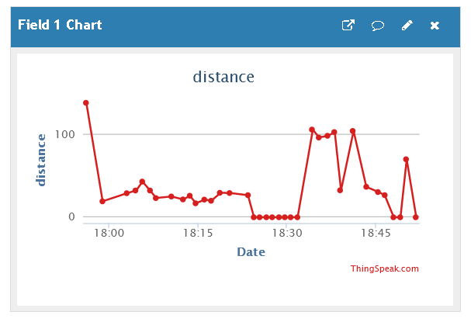

Q4: Create a repository named SIT210-Task3.1P-WebHook on Github. Upload your code to the repository. Include the link to your repository here.

<https://github.com/radhikara/SIT210-Task3.1P-WebHook>

Q5: Describe a real-life usage scenario for your system (less than one paragraph).

Webhook for real-life usage scenario can be used for traffic sensors, smart home appliances (smart TV, smart AC, etc).